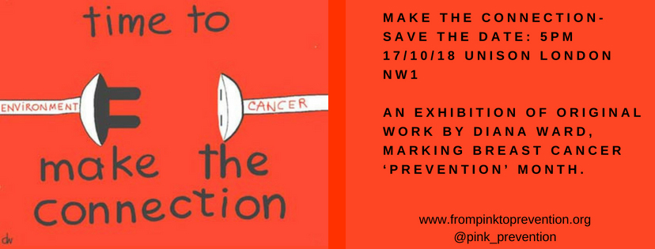

Message of Support from Helen Hayes MP
Brexit will impact every aspect of our health from R & D, to care and nursing staff, and we already see the effects of this with the shocking drop of 95% of EU nationals applying for nursing in the UK since Brexit.
One such aspect that doesn't get much attention, but should, is chemicals regulation.
In recognition of the critical need to regulate chemicals - especially those that that are harmful to health and environment the UK needs to stay in REACH (the European Chemicals regulations - which by the way the UK had a large part in formulating) and as associate member of the European Chemicals Agency (ECHA).
Every day new evidence comes to light on the links between environmental factors and cancer. In addition to the regulation of chemicals, EU-derived laws on worker health and safety, water pollution, and factory emissions, are also crucial to the safe management of chemicals in our workplaces and in our environment.
These laws are not a ‘barrier to trade’, they protect our health in the home and in the workplace. They also protect our wildlife and environment. It’s hard to envisage the present government producing better regulation on chemicals like endocrine disruptors when they are seen as something which can be bargained away in future trade deals with other countries.
I was delighted to host From Pink to Prevention's event last year at Portcullis House, to mark Breast Cancer Awareness Month. That event asked the question: what links Brexit and breast cancer? Their answer was REACH. Whatever the outcome of Brexit, we did not vote for the reduced protection oof our health, and in our workplace and wider environment.
We must do all we can to lobby the government to ensure that the Brexit deal keeps the UK within the EU chemicals regulatory body, ECHA and under the REACH legislation.
I'm sorry I can't be with you all tonight, at this event supported by UNISON but I send my very best wishes and support for all the effort made by groups like From Pink to Prevention who are drawing attention to the need for ever stronger - not weaker - regulations on all chemicals harmful to our health and environment.

